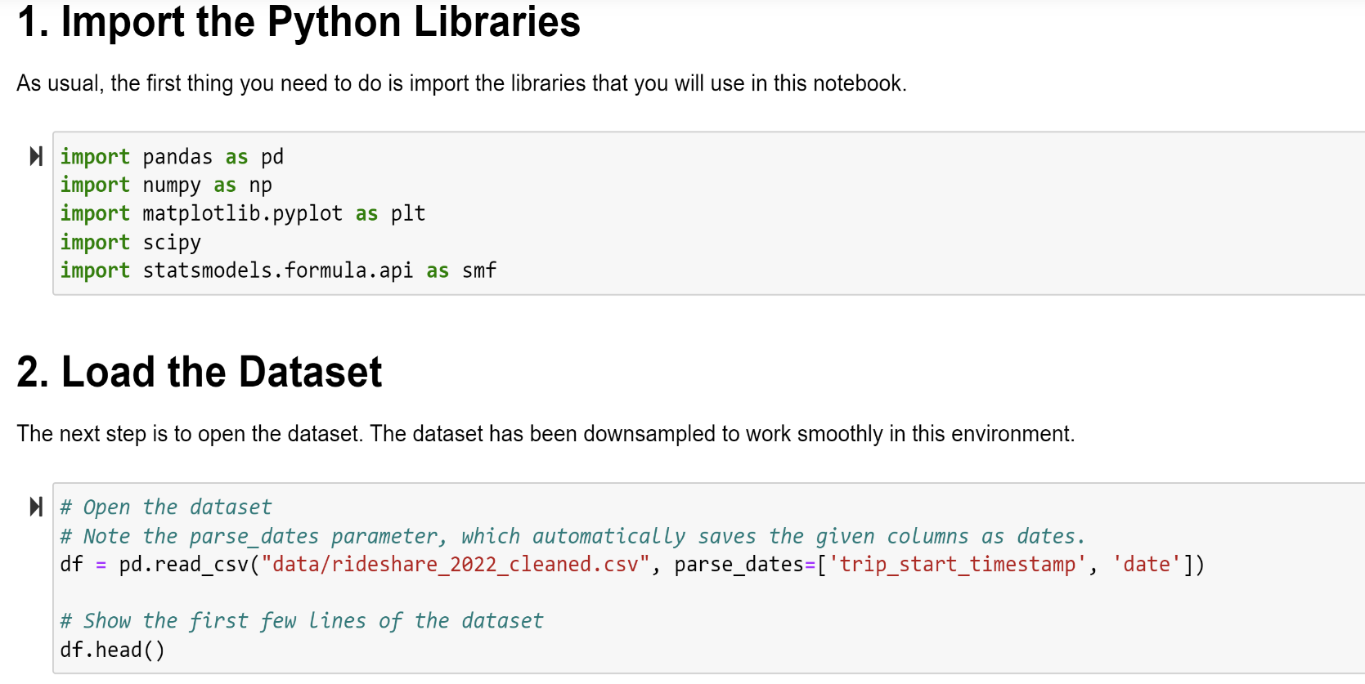

Group BY:

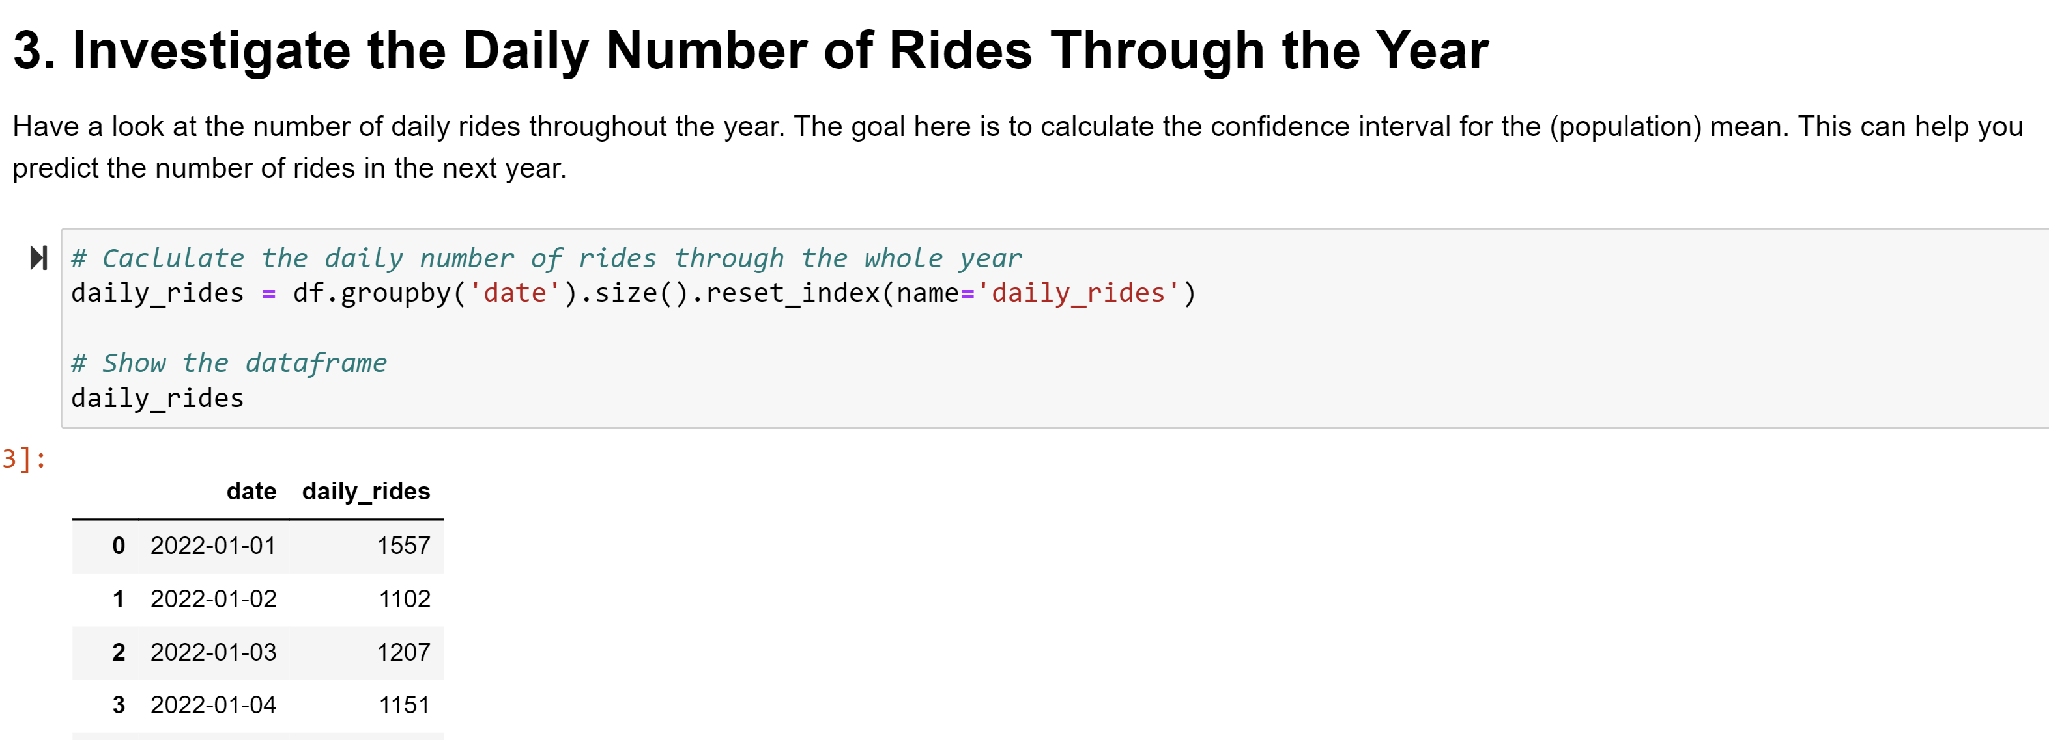

Calculate mean and standard deviation

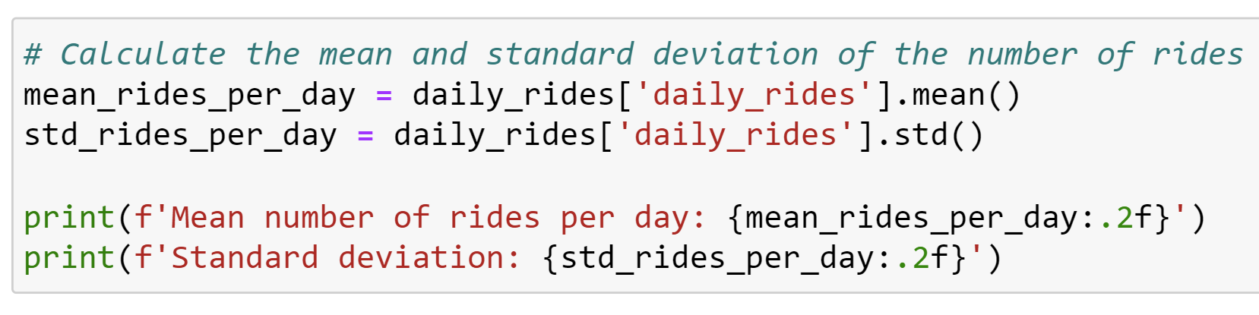

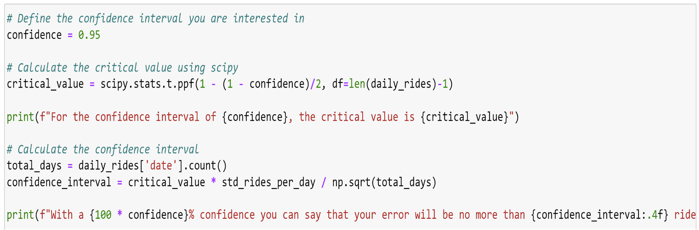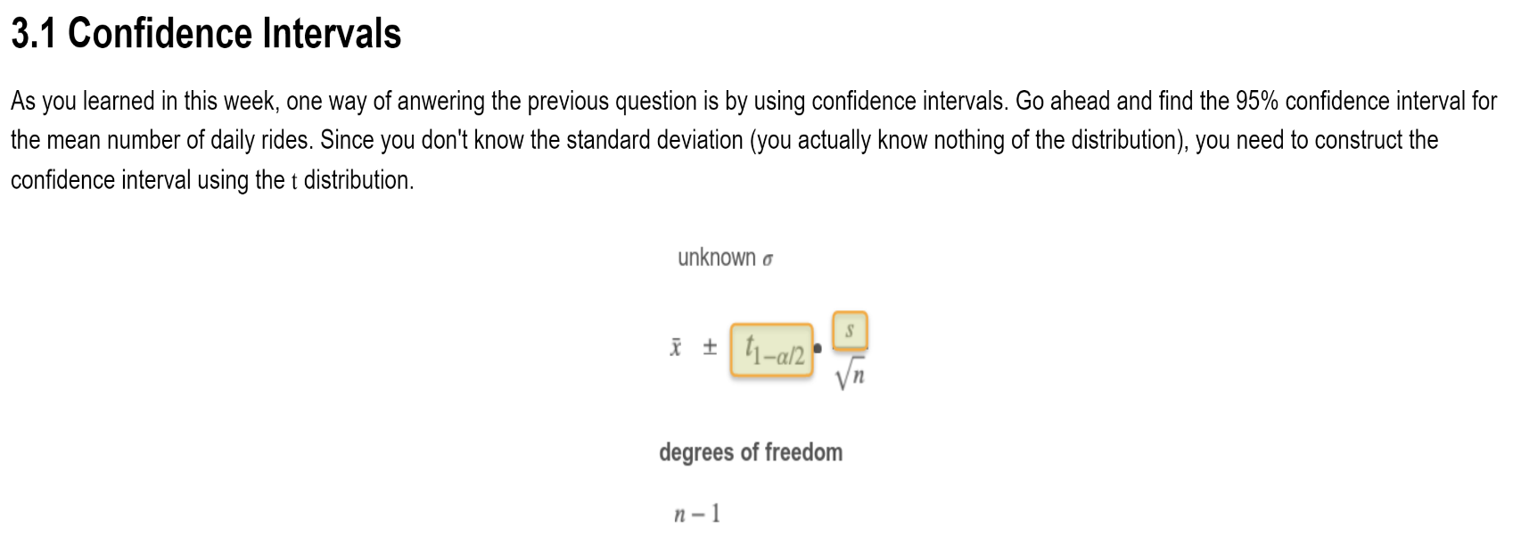

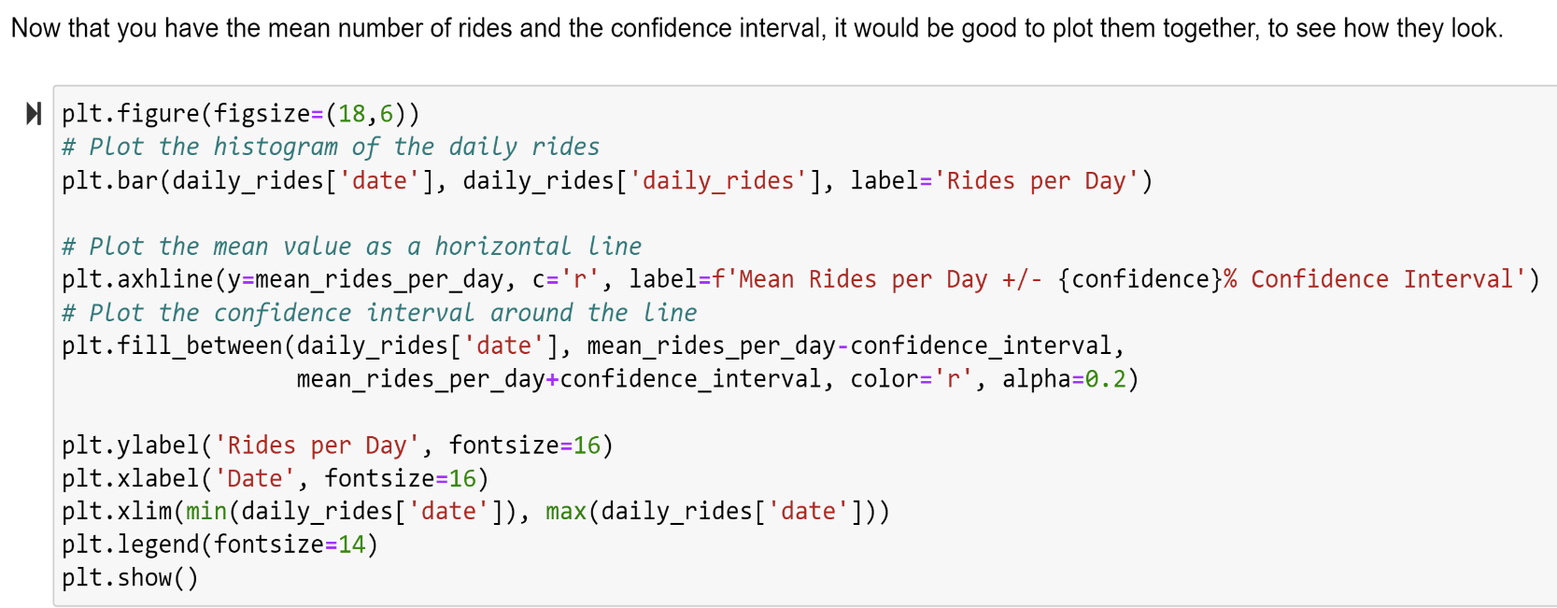

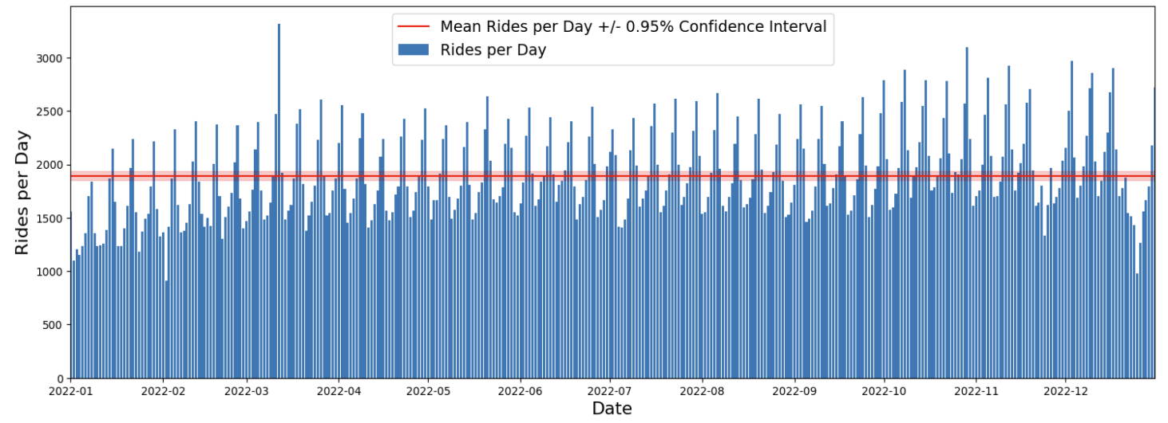



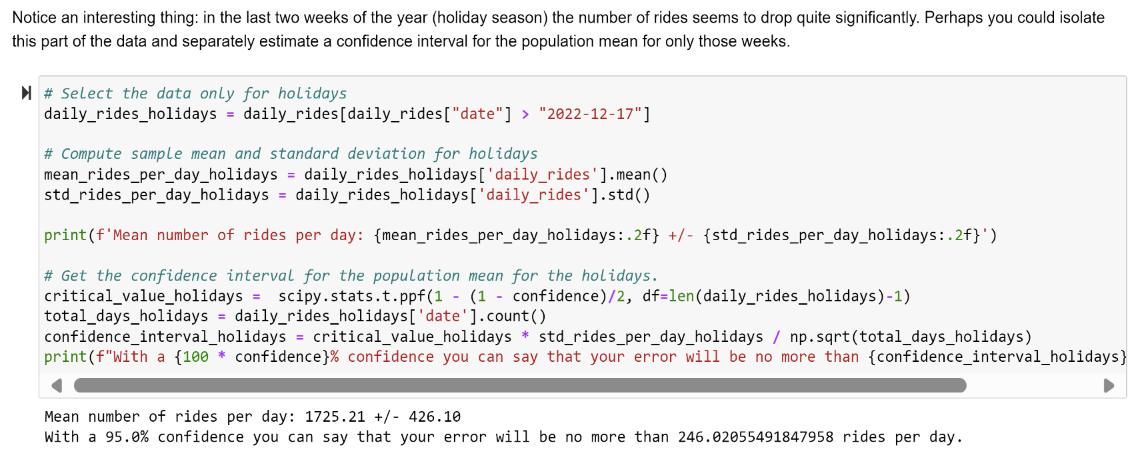

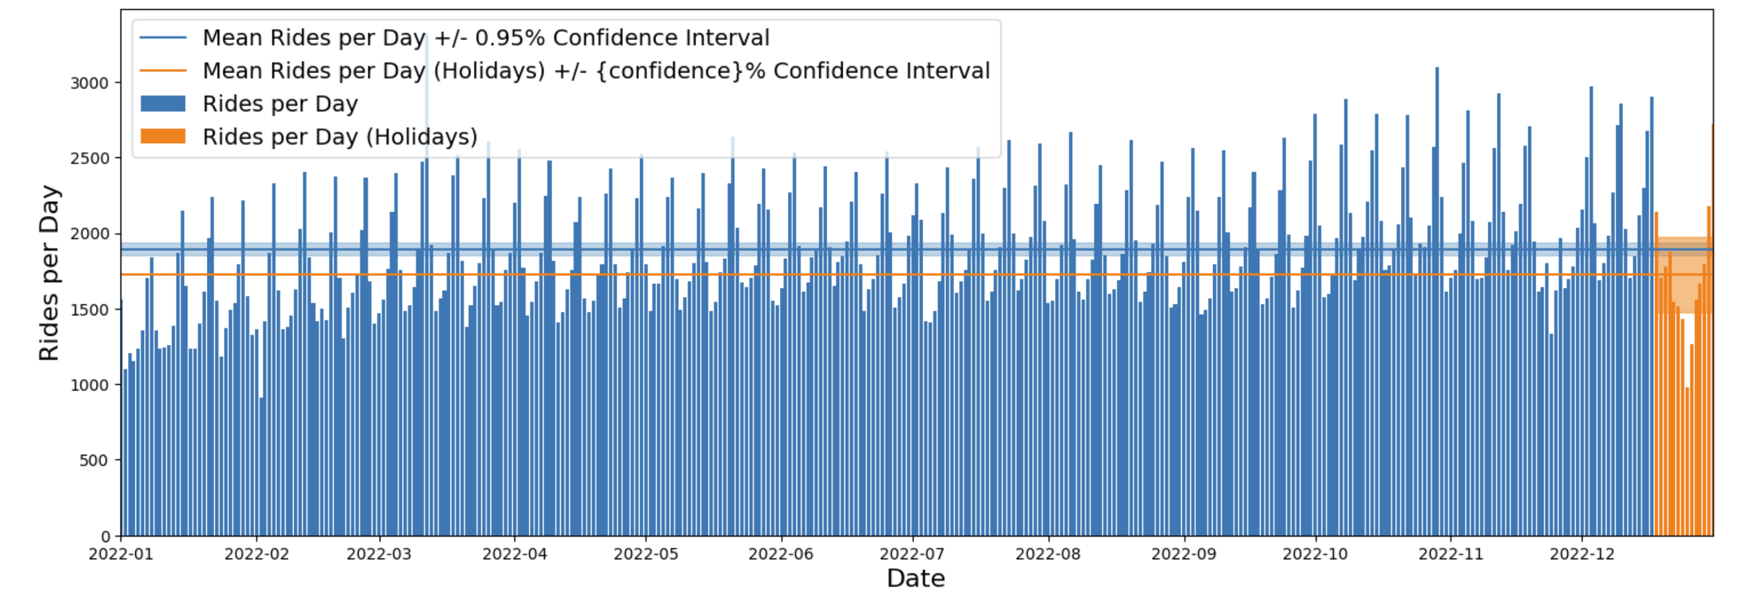

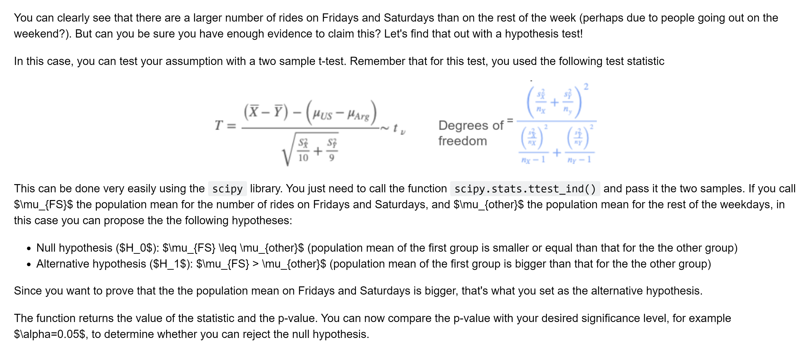

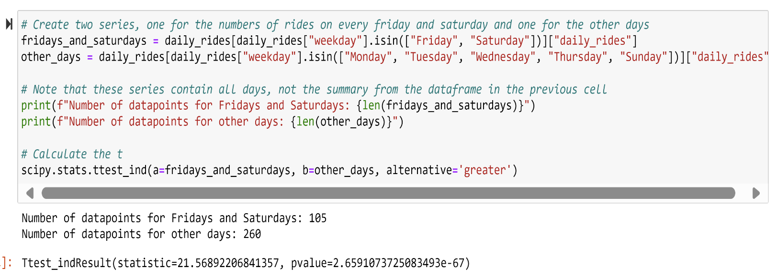

**Linear Regression回归模型：**

OLS Statistic统计学方法：

statsmodels library [statsmodels 0.14.1](https://www.statsmodels.org/stable/index.html)

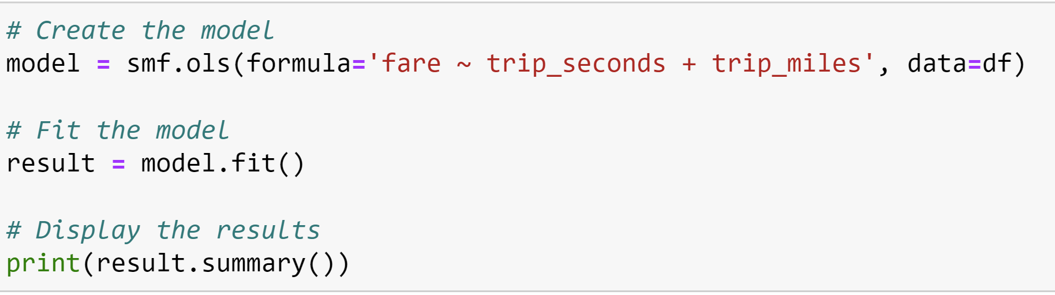

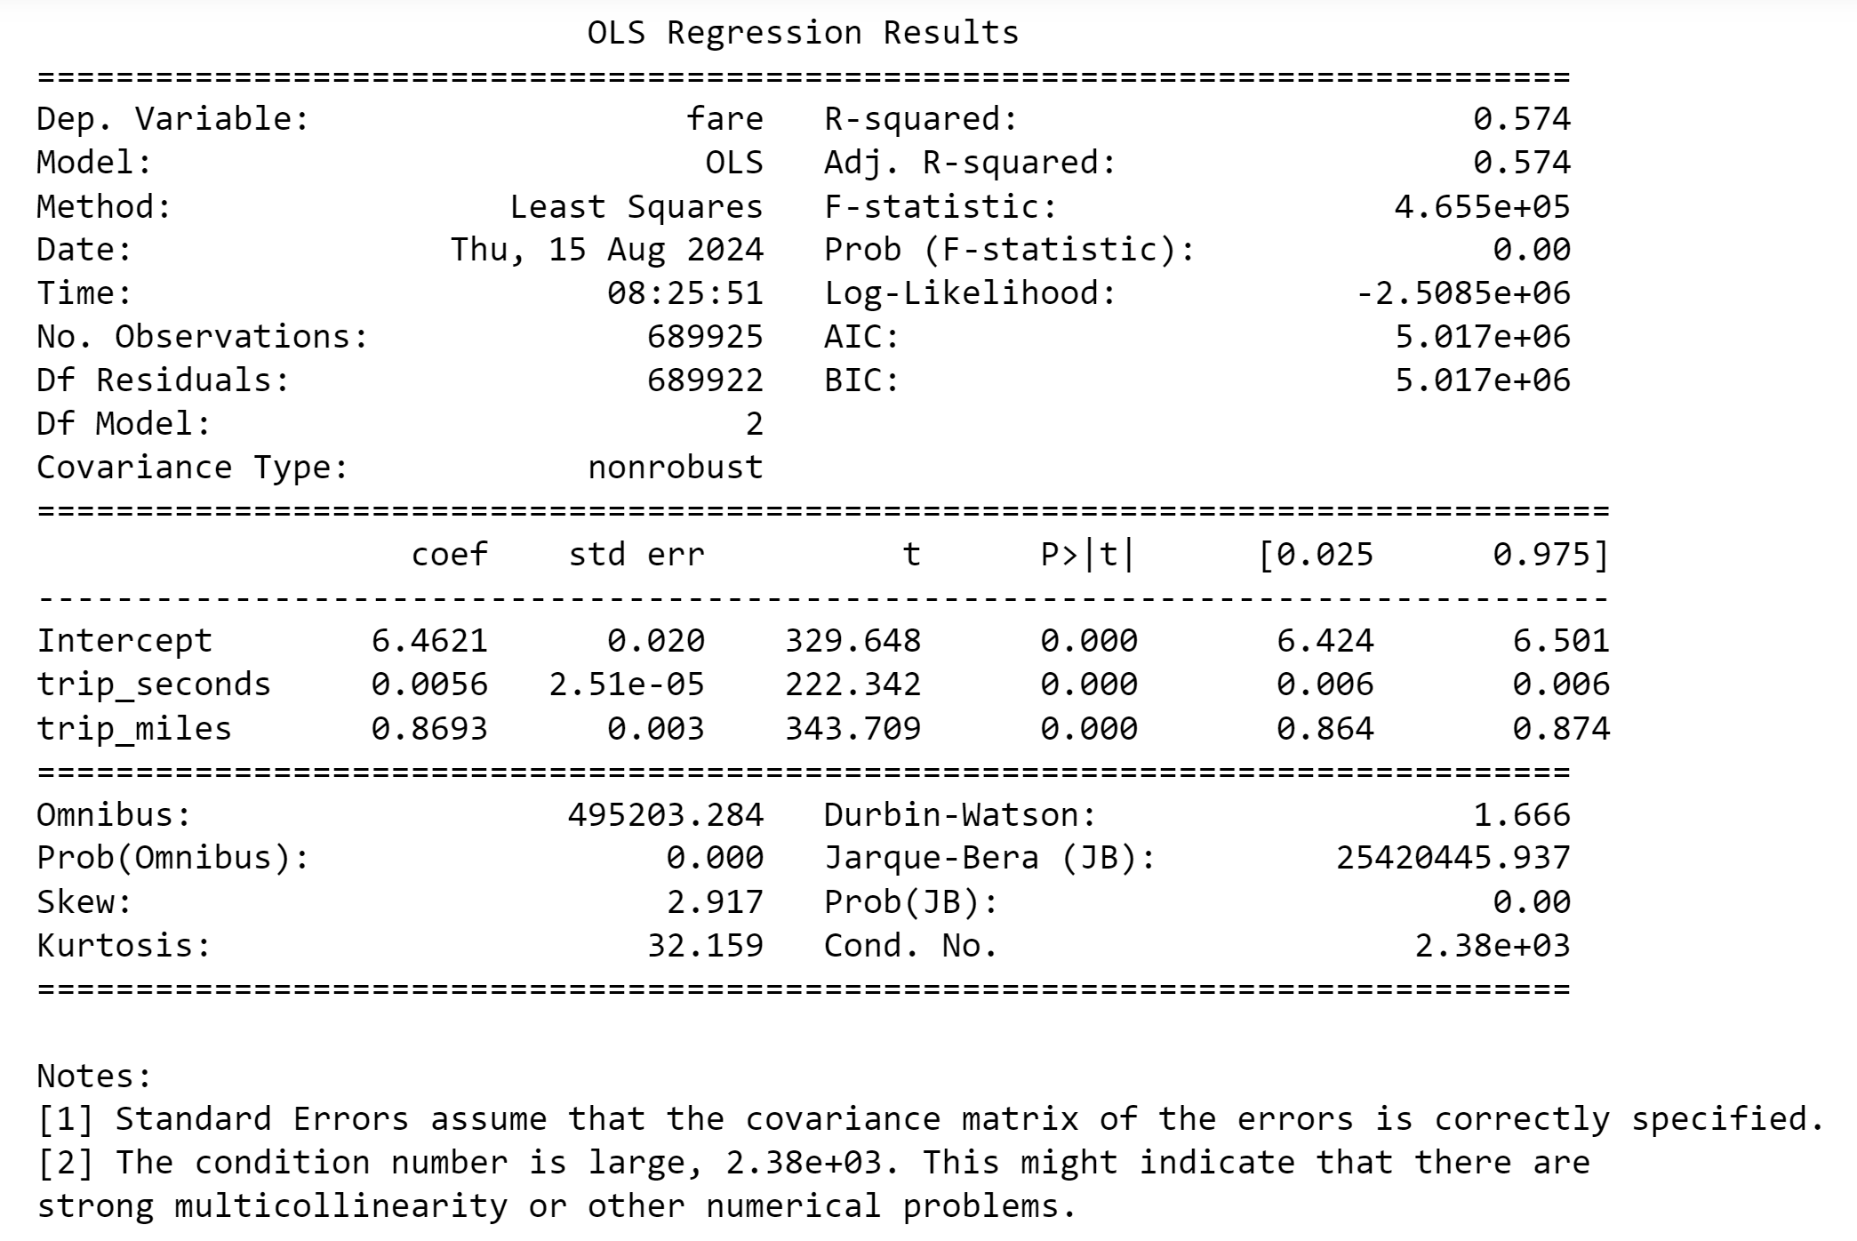

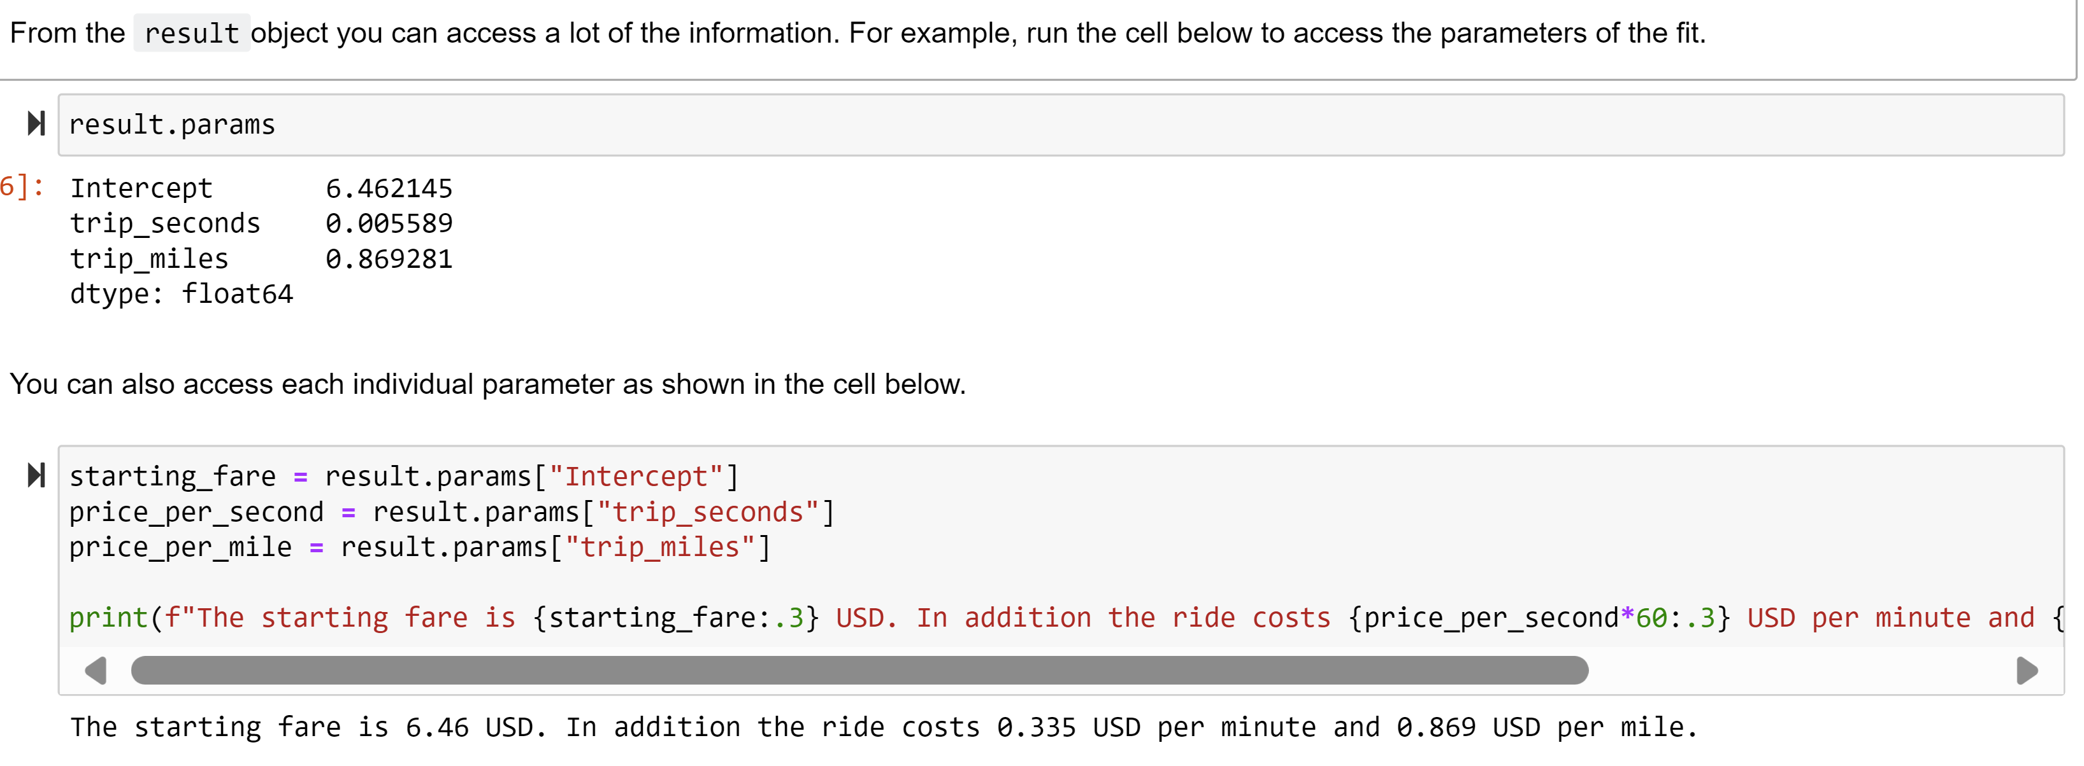

Skew and kurtosis give you the skewness and kurtosis of the residues. Remember that the residue is the squared difference between your observation and the predicted output of the model. It is a good way to know how the errors of the model are distributed.

This is the last of the values you can actually completely understand from what you've seen on this course. However, there are more that you can at least intuitively understand. Both (Omnibus and Prob(Omnibus)) and (Jarque-Bera (JB) and Prob(JB)) represent hypothesis tests.

The values of Omnibus and Jarque-Bera (JB) are the values of the statistic of each test, while Prob(Omnibus) and Prob(JB are the p-values. Note that in both of this tests, a small p-value indicates that the residues are not normally distributed.残差不是正态分布则模型fit的有问题。意味着将来进行predicate时在某些阶段会注定有大的误差。

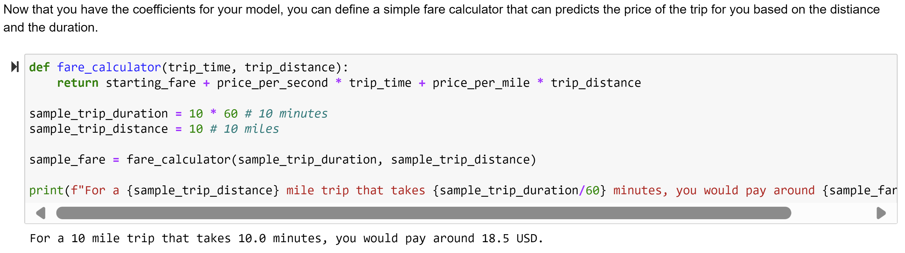

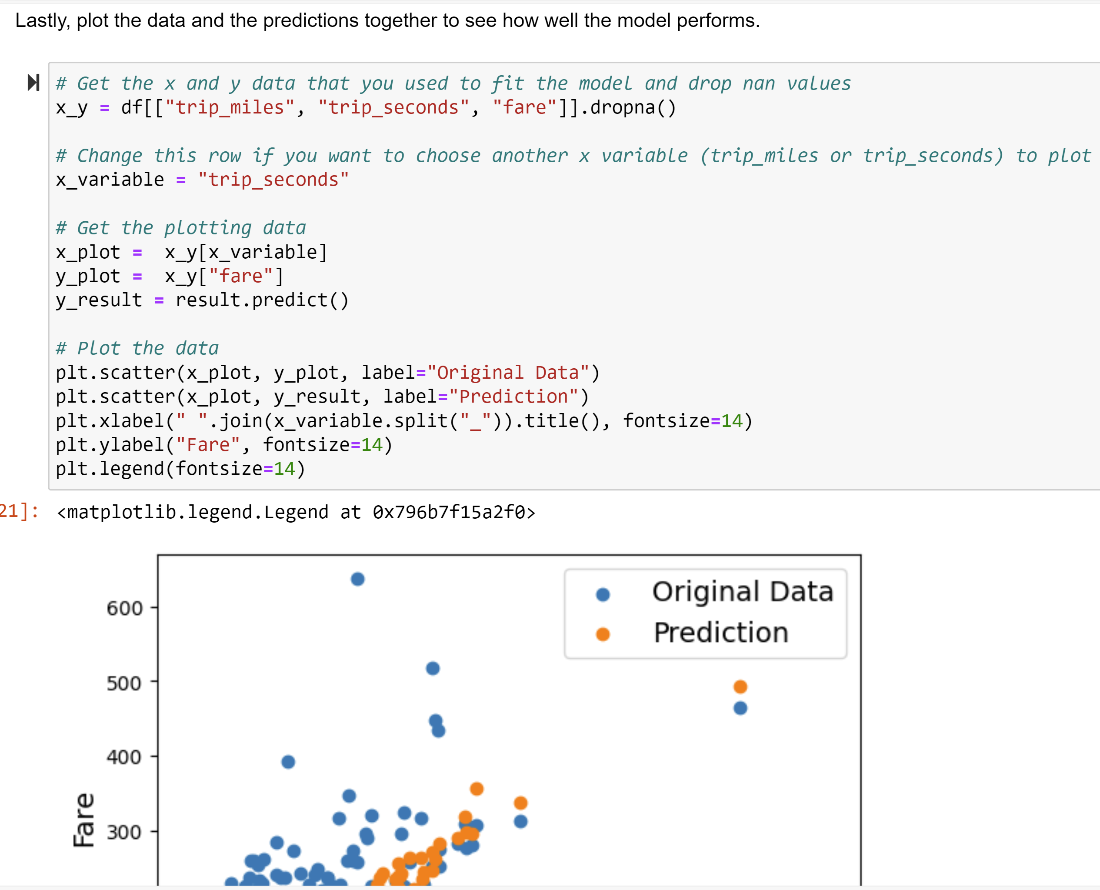

**除了statsmodel之外，还可以用概率学ML方法来进行回归模型建立：**

**scikit-learn library** [**scikit-learn: machine learning in Python — scikit-learn 1.5.1 documentation**](https://scikit-learn.org/stable/index.html)

